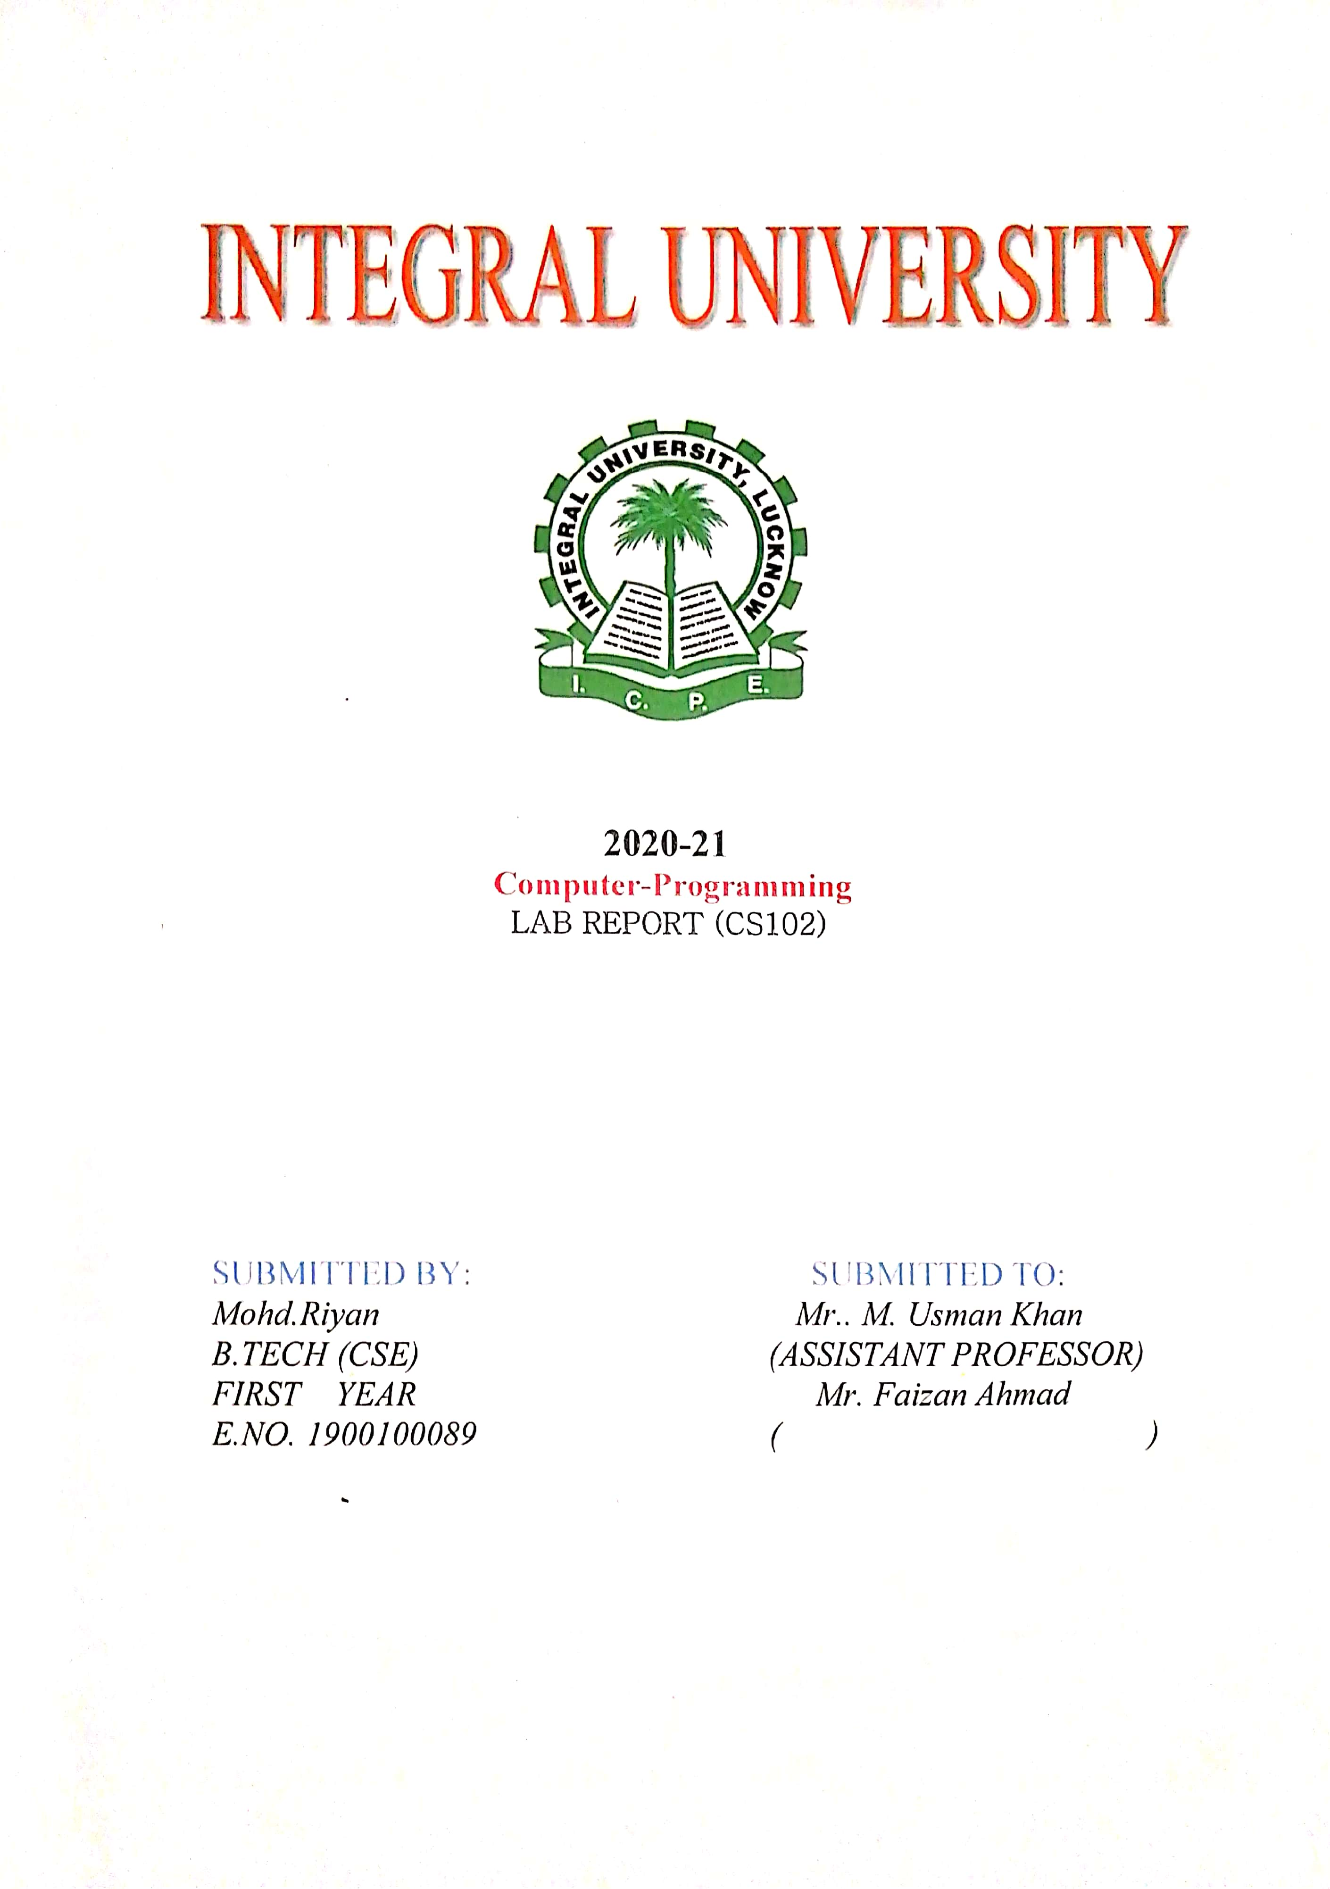

**2021-22**

**Microprocessor Lab Report**

**(CS-314)**

**SUBMITTED BY: SUBMITTED TO:**

**Mohd Riyan** **Mr. Badaruzzaman**

**B. TECH (CSE)** **Dr. Mohammad Zunnun Khan**

**Group: CSE-2**

**3rd Year 6th Sem**

**E.NO. 1900100089**

**Roll.no 1901012131**

**ACKNOWLEDGEMENT**

I would like to acknowledge and extent my heartful gratitude to **Mr. Badaruzzaman** and **Dr. Mohammad Zunnun Khan** under whose guidance I have prepare the **Microprocessor Lab.**

They have been a constant source of encouragement and inspiration to me.

I am also indebted to my batch mated who have been great help in the preparation of this Lab Report.

**NAME : MOHD RIYAN**

**EN.NO : 1900100089**

**CERTIFICATE**

This is to certify that **MOHD RIYAN** of **B. TECH** Third year has sincerely completed his **“ Microprocessor Lab”** & submitted it on time & has helped to maintain the decorum of LAB.

**Mr. Badaruzzaman Dr. Mohammad Zunnun Khan**

**INDEX**

|  |  |  |  |  |
| --- | --- | --- | --- | --- |
| **SL.NO** | **OBJECTIVE** | **DATE** | **REMARKS** | **SIGNATURE** |
| **1** | **Write a program to two add 16 bit Hexadecimal numbers without carry** |  |  |  |
| **2** | **Write a program to two add 16 bit Hexadecimal numbers with carry** |  |  |  |
| **3** | **Write a program to find the greatest number from an array of 10 numbers** |  |  |  |
| **4** | **Write a program to calculate the factorial of a number** |  |  |  |
| **5** | **Write a program to multiply two 16-bit numbers result should be greater than 16 bit** |  |  |  |
| **6** | **Write a program to input 5 numbers and arrange them in descending order** |  |  |  |
| **7** | **Write a program to convert the string data it’s Two’s complement form** |  |  |  |
| **8** | **Write a program to read 8 bit data from Port B. Complement this data & send it back to Port A of** |  |  |  |
| **9** | **Write a program to move a block of data from one memory location to another** |  |  |  |
| **10** | **Write a program to find Gray code equivalent of a Binary number using Lookup Table** |  |  |  |
| **11** |  |  |  |  |



**2021-22**

**Compiler Design Lab Report**

**(CS-316)**

**SUBMITTED BY: SUBMITTED TO:**

**Mohd Riyan Mr. Mohd Ishaaq**

**B. TECH (CSE) Mr.**

**Group: CSE-2**

**3rd Year 6th Sem**

**E.NO. 1900100089**

**Roll.no 1901012131**

**ACKNOWLEDGEMENT**

I would like to acknowledge and extent my heartful gratitude to **Mohd Ishaaq** and **Mr.** under whose guidance I have prepare the **Compiler Design Lab Report.**

They have been a constant source of encouragement and inspiration to me.

I am also indebted to my batch mated who have been great help in the preparation of this Lab Report.

**NAME : MOHD RIYAN**

**EN.NO : 1900100089**

**CERTIFICATE**

This is to certify that **MOHD RIYAN** of **B. TECH** Third year has sincerely completed his **“Compiler Design Lab Report”** & submitted it on time & has helped to maintain the decorum of LAB.

**Mr. Mohd Ishaaq Mr.**

**INDEX**

|  |  |  |  |  |
| --- | --- | --- | --- | --- |
| **SL.NO** | **OBJECTIVE** | **DATE** | **REMARKS** | **SIGNATURE** |
| **1** |  |  |  |  |
| **2** |  |  |  |  |
| **3** |  |  |  |  |
| **4** |  |  |  |  |
| **5** |  |  |  |  |
| **6** |  |  |  |  |
| **7** |  |  |  |  |
| **8** |  |  |  |  |
| **9** |  |  |  |  |
| **10** |  |  |  |  |
| **11** |  |  |  |  |



**2021-22**

**Computer Networks Lab Report**

**(CS-316)**

**SUBMITTED BY: SUBMITTED TO:**

**Mohd Riyan Mr. Amit Kumar Srivastav**

**B. TECH (CSE) Mr.**

**Group: CSE-2**

**3rd Year 6th Sem**

**E.NO. 1900100089**

**Roll.no 1901012131**

**ACKNOWLEDGEMENT**

I would like to acknowledge and extent my heartful gratitude to **Amit Kumar Srivastav** and **Mr.** under whose guidance I have prepare the **Computer Networks Lab Report.**

They have been a constant source of encouragement and inspiration to me.

I am also indebted to my batch mated who have been great help in the preparation of this Lab Report.

**NAME : MOHD RIYAN**

**EN.NO : 1900100089**

**CERTIFICATE**

This is to certify that **MOHD RIYAN** of **B. TECH** Third year has sincerely completed his **“Computer Networks Lab Report”** & submitted it on time & has helped to maintain the decorum of LAB.

**Amit Kumar Srivastav Mr.**

**INDEX**

|  |  |  |  |  |
| --- | --- | --- | --- | --- |
| **SL.NO** | **OBJECTIVE** | **DATE** | **REMARKS** | **SIGNATURE** |
| **1** |  |  |  |  |
| **2** |  |  |  |  |
| **3** |  |  |  |  |
| **4** |  |  |  |  |
| **5** |  |  |  |  |
| **6** |  |  |  |  |
| **7** |  |  |  |  |
| **8** |  |  |  |  |
| **9** |  |  |  |  |
| **10** |  |  |  |  |
| **11** |  |  |  |  |